Medication Review

It is important to keep up to date with medication reviews, to ensure you are on the most beneficial medication and dose.

Medication review can be done over the telephone providing you are up to date with blood tests and have provided a recent blood pressure reading (if applicable).

Please contact the practice for further information.
Self-Care Without Needing To See Your GP

Many medicines for minor ailments can be bought at low cost or FREE over the counter at your local pharmacy without you needing to see a GP. Most are open late nights and weekends and no appointment is needed.
Your local pharmacy can help you with the following:

- Coughs, colds and sore throats
- Hayfever and allergies
- Eye infection
- Constipation and diarrhoea
- Acne and eczema
- Minor aches and pains
- Thrush
- Threadworms
- Nappy rash
- Mouth ulcers
- Haemorrhoids

So before you make an appointment to see your Doctor think ‘Could I treat this myself at my local pharmacy?’

*IMPORTANT NOTICE* - COVID19!

** Everyone must stay at home to help stop the spread of coronavirus - Do not go to a GP surgery, community pharmacy or hospital. Call 111, stay indoors and avoid close contact with other people. **

You should only leave the house for 1 of 4 reasons:
- shopping for basic necessities, for example food and medicine, which must be as infrequent as possible
- one form of exercise a day, for example a run, walk, or cycle – alone or with members of your household
- any medical need, or to provide care or to help a vulnerable person
- travelling to and from work, but only where this absolutely cannot be done from home

Even when doing the below activities, you should be minimising time spent outside of the home and ensuring you are 2 metres apart from anyone outside of your household

Do not leave your home if you have either:
- a high temperature – this means you feel hot to touch on your chest or back (you do not need to measure your temperature)
- a new, continuous cough – this means coughing a lot for more than an hour, or 3 or more coughing episodes in 24 hours (if you usually have a cough, it may be worse than usual)

For further questions and advice, please contact the practice on 01706397666

Spring/Summer 2020 Issue – the practice will produce a newsletter to keep you updated with the latest changes which are taking place in the practice and the NHS.
Changed your number?

If you have changed your phone number or home address, don’t forget to let us know as
soon as possible!
1st Floor, Nye Bevan House, Maclure Road, Rochdale, Lancashire, OL11 1DN
Reception Line: 01706 397666
Prescription Line: 01706 397665
Fax Line: 01706 397667

Online Services

Have you signed up to use our online services? It’s a simple and easy way of:

- Ordering repeat prescriptions
- Booking routine appointments
- Cancelling a booked appointment
- Viewing a summary of your medical record

To use these services you will need to provide your email address and we will issue you a unique username and password.

During this difficult period for the NHS services, having online access could be more efficient for patients and the practice.

RUClear is a service for people aged 16 to 24 years that offers confidential tests from the NHS, for the sexually transmitted infections (STIs) chlamydia, gonorrhoea, HIV and syphilis.

If you would like further information on how to receive a screening, for some or all of these infections please telephone on 0800 046 1303.
Self-Referrals

The following services are available for you to self-refer if you require them. If you do not contact any of them be sure to mention that you are a patient at Dr MB Ghafoor & SA Abbasi so that your doctor receives any corresponding paperwork.

New podiatry self-referral form*
There is a podiatry referral form available which allows patients to access podiatry services without seeing a GP first.

Physio self-referral
There is a physio direct referral form also available for patients suffering from musculoskeletal problems.

Living well
This service works with other organisations to support people to be healthier, happier and live longer by focusing on; stopping smoking, healthy eating, weight management and low mood

Thinking ahead
Thinking Ahead helps with everyday issues that affect your mental wellbeing and provides professional support for more common mental health difficulties, such as anxiety and depression.

Please speak to reception for further information regarding these referrals.

Or completing a form

Useful Numbers & Websites

Patient Participation Group

The group meets every 3 months to discuss future plans for the surgery and get patient’s input.

If you are interested in improving the service locally and would like to participate in the Patient Participation Group, please let us know!

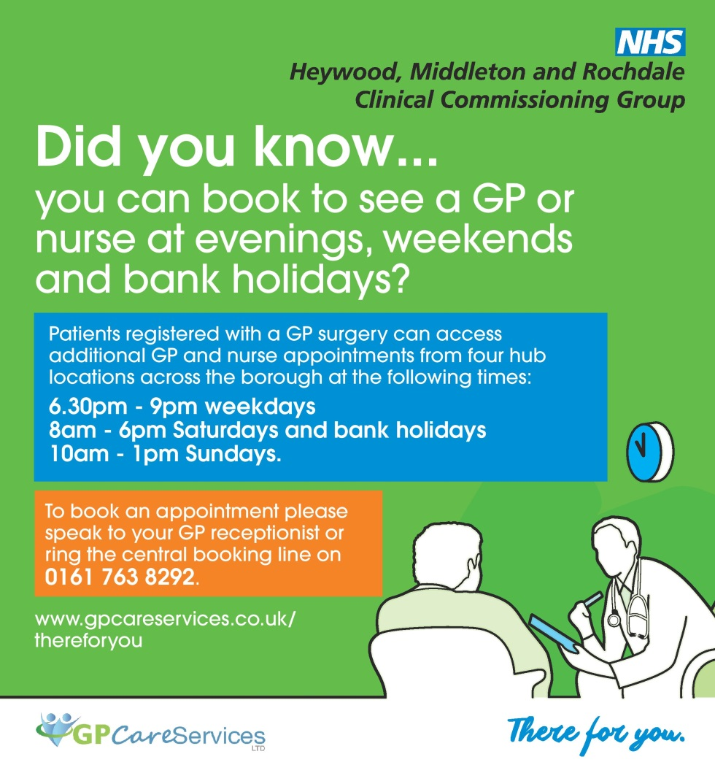

NHS (out of hours) | 111
7 Day Access | 0161 763 8292
Rochdale Infirmary | 0161 624 0420
Thrive (Children) | 0161 716 2824
Midwife | 01706 517223
Paediatric Nurse | 01706 676777
Ear Syringing | 01706 676067
Thinking Ahead | 01706 751180
Living Well | 01706 751190
Weight Management | 01706 751190
RU Clear | 0800 046 1303
Contraceptive Service | 0300 303 8565

www.nhs.uk
www.patient.co.uk
www.netdoctor.co.uk
www.drghafoorandpartners.co.uk/

Why does my receptionist need to ask what’s wrong with me?

Active Signposting – It is not a case of the receptionists being nosey!

Getting to see a GP or a nurse when you really need to do so is not easy. There are many reasons for this:

- There is s shortage of GPs and nurses and so there is not enough appointments to meet the demand
- Resources are limited
- Appointments are taken up when sometimes the GP / Nurse is not the best person to deal with your needs.
- 1 in 4 GP appointments could have been better dealt with by other healthcare professionals

To help address these problems, the local Clinical Commissioning Group has developed an ‘Improving access to general practice scheme’ which requires all practices, working in partnership, with Rochdale Health Alliance, to implement some changes which are intended to improve access.

These changes are happening in every practice across HMR. All our receptionists have undergone training for active signposting.

How will this affect you?

The main change that you will experience is that the receptionist will ask you some questions that will ensure that you receive:

- the most appropriate medical care,
- from the most appropriate health professional,
- at the most appropriate time

This will enable doctors to prioritise home visits and telephone consultations and therefore ensuring patients receive the appropriate level of care.

Reception staff, like all members of the practice team, are bound by confidentiality rules and any information given by you is treated in the strictest confidence. The can also request to speak to a receptionist privately if you feel uncomfortable discussing any issues you have at the desk.

Please help the receptionist to help you by answering the questions

Thank you for your support

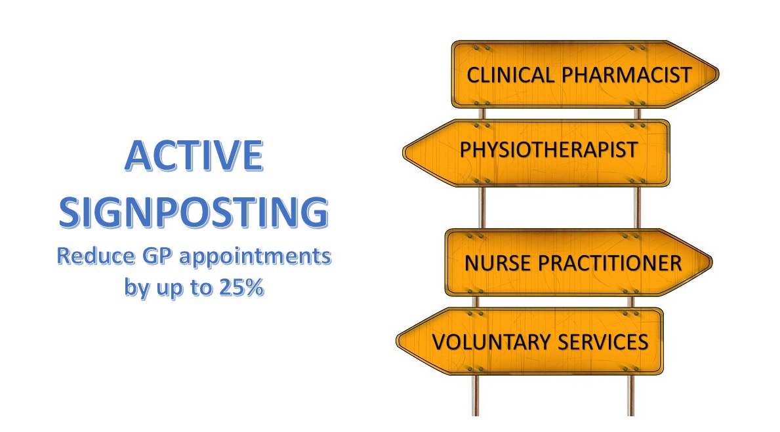

No job openings at the moment

Please keep posted for future changes!

